Configurator–Typical IWP Configuration

Instructions for creating a new quote

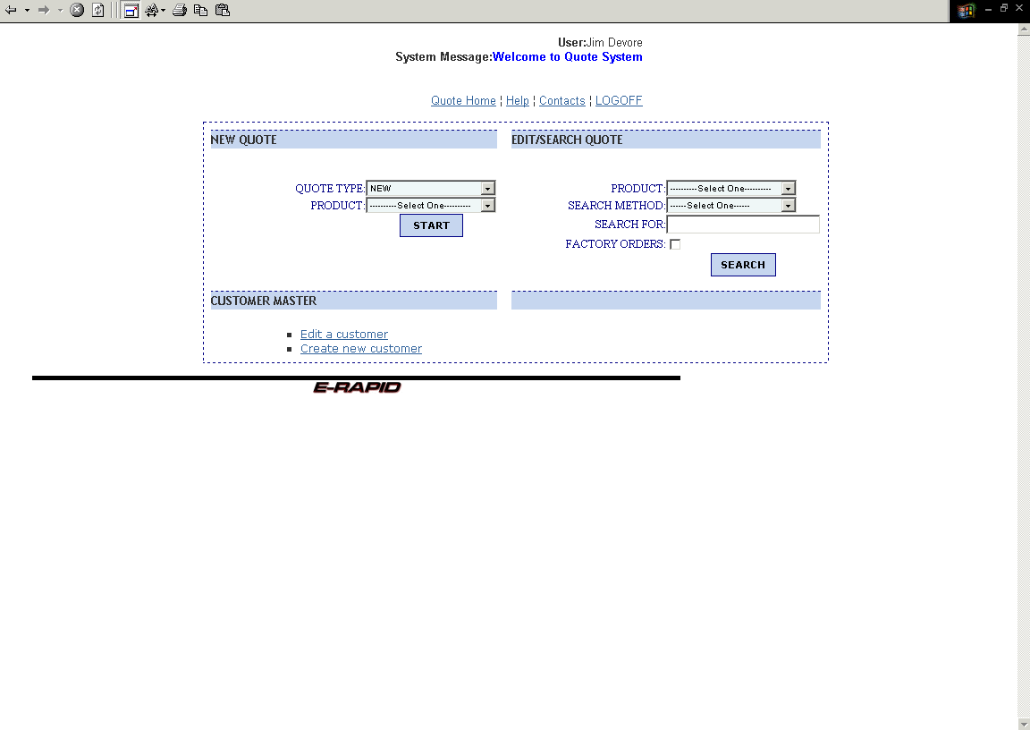

- The initial screen once into e-rapid quoting allows you to enter a new quote, edit existing quotes, edit an existing customer, create a new customer, or search for a factory quote.
- Press the F11 function key to get a full screen mode.
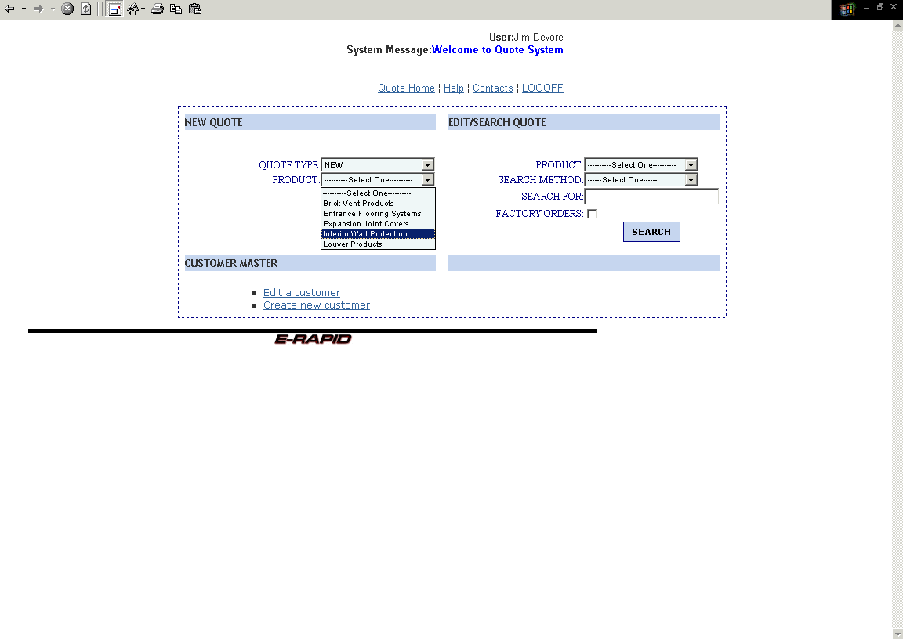
- To enter a new quote, pull the drop down screen to get the product. In this case, Interior Wall Protection.
- Hit the start button (hidden by the drop down box in this picture).
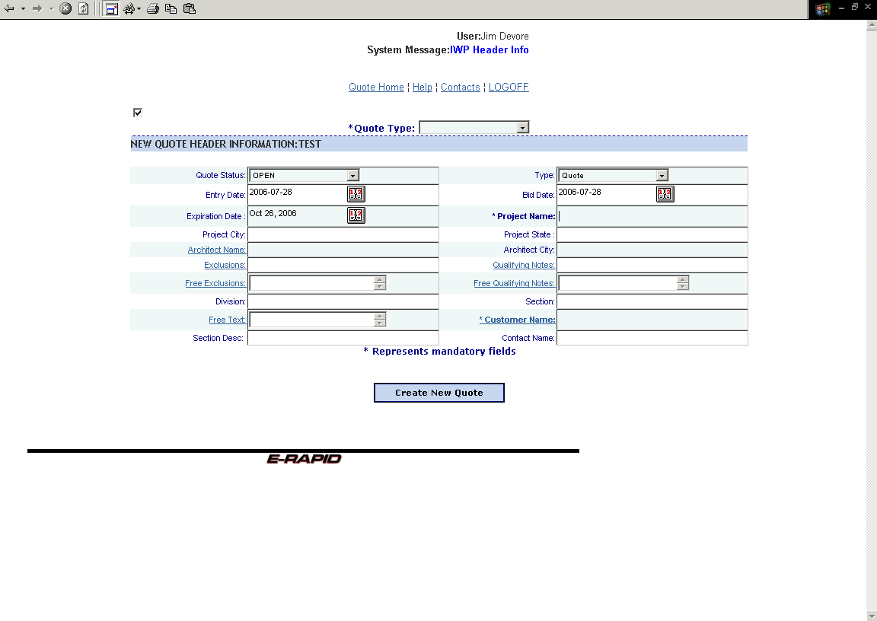
- This is the header screen.
- Mandatory fields are quote type (see below), project name, and customer name (see below).
- Architect information can be added by clicking on Architect Name.
- Qualifying notes are available by clicking on the appropriate header, as are custom exclusions (free exclusions), custom qualifying notes (free qualifying notes), and additional text (free text).
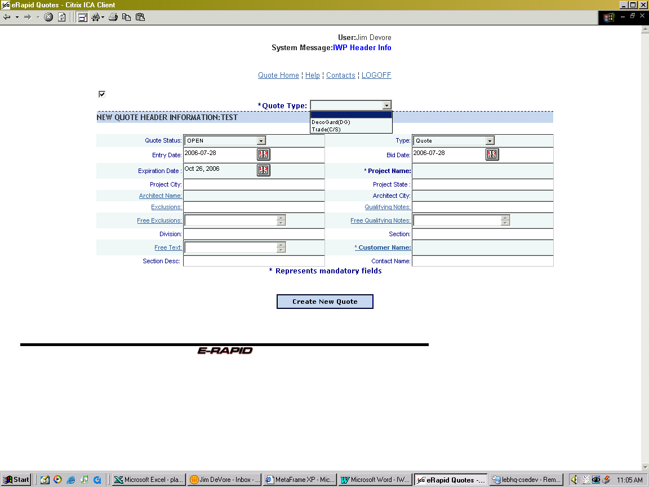
- Drop down box for quote type, C/S or DecoGard.

- Customer look-up or add screen.
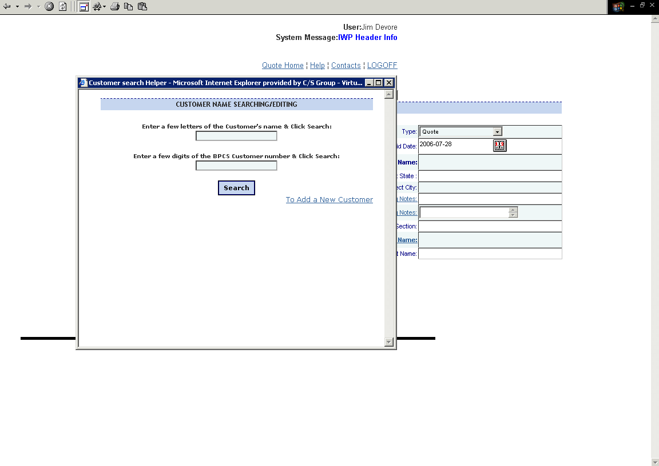
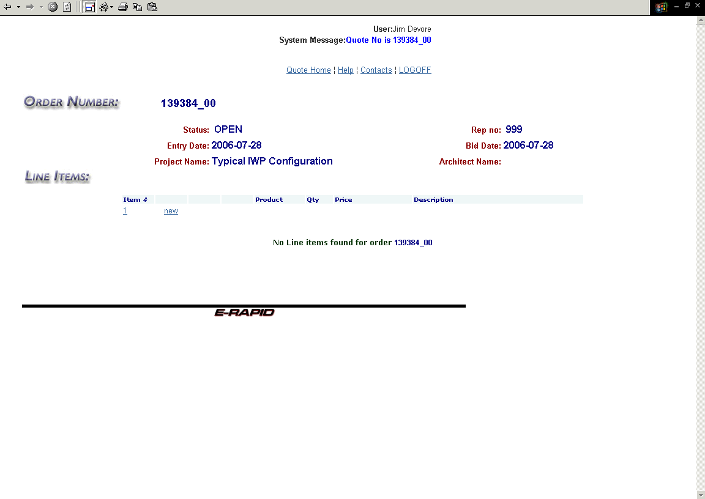
- This is the line item list. As products or different line items are created, they are added to this list.
- To return to the header screen click on the Item # (1 in this example).
- Write down the quote number (order number) for future reference.
- Click on the “new” text to add products through the configurator.
- The initial configurator screen brings up the product group box.
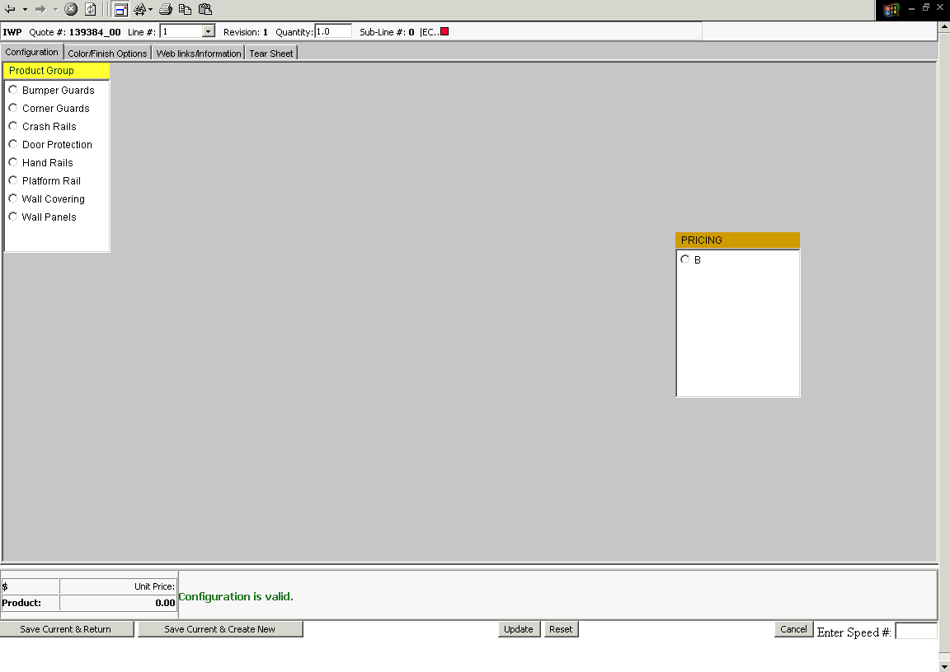
- Note the tabs at the top of the screen:
- Configuration – This is the area in which specific product information is added, as will be shown in this script.
- Color/Finish Options – Once the information in the Configuration screen is complete, clicking this tab will enable you to select from the various color and finish options available to the specific product selected. It is not mandatory to fill this information in at the quote stage, but will be required to convert to an order. If this information is known at the time of quote, it is highly recommended to use this screen at the quote phase to save effort when converting to an order.
- Web Links/Information – This is the screen in which product information can be obtained from the C/S web site. It also contains product specific information such as standard kick plate sizes.
- Tearsheet tab – This screen will preview the model selected.

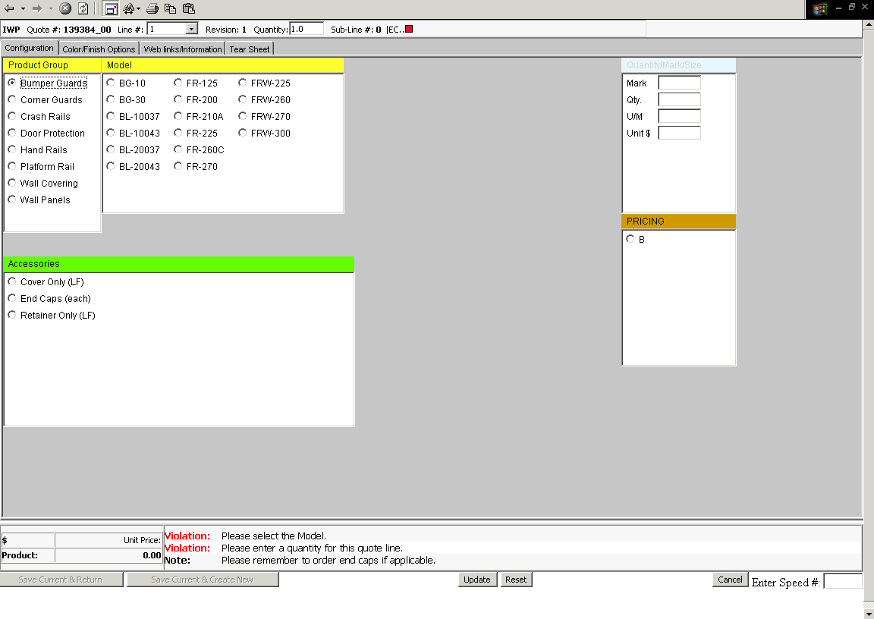
- Once a product group is selected, available information specific to that group is available for selection.
- Note the information shown on the lower center of the screen is there to assist you in proceeding through product configuration. Notice that the first line advises that a model selection is required.
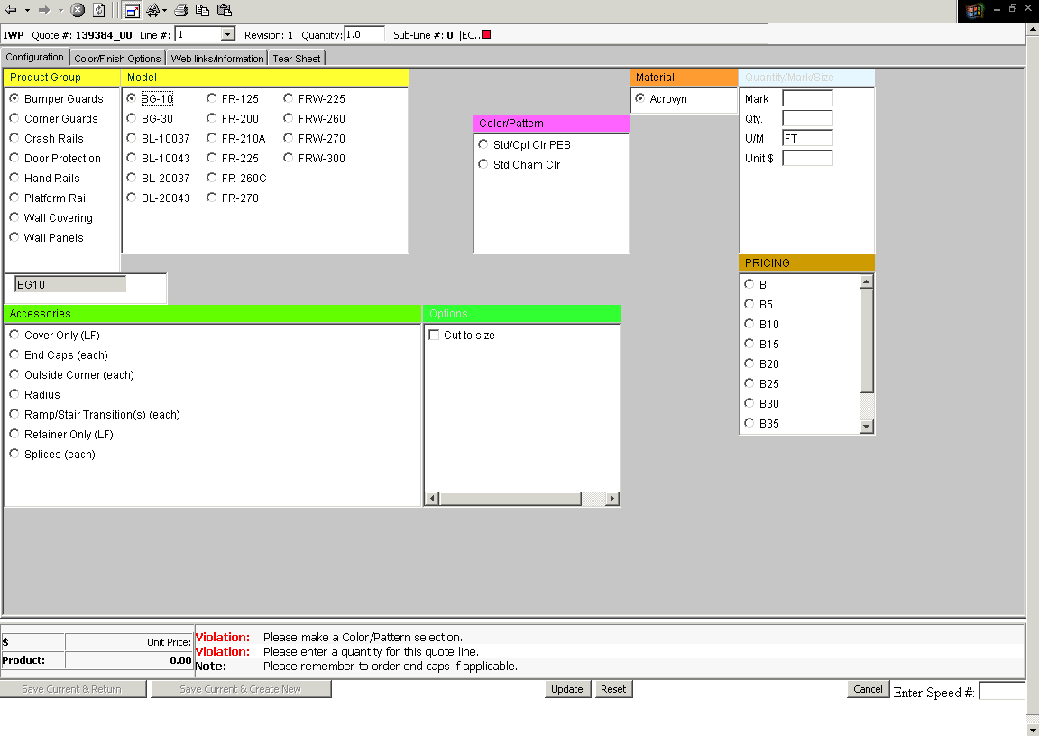
- Once a model is selected, additional information populates the screen.
- Using the script in the lower center of the screen, you can see that a color/pattern selection is required and a quantity must be inserted. Note that quantity is based upon linear feet or each depending upon the selection (shown as UM in the upper right box).
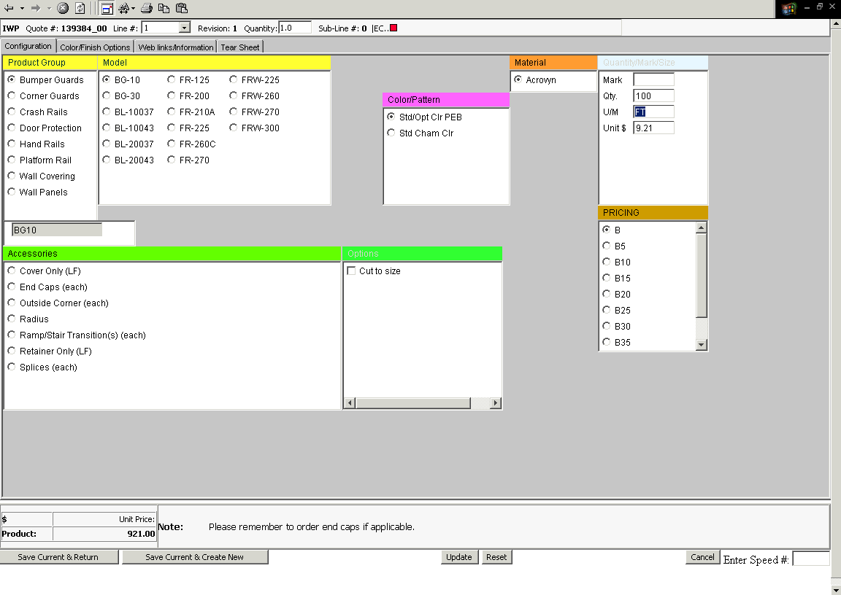
- You must click or tab out of the quantity box once entered. You may see a violation indicating that pricing is only available through the factory, which is possibly due to a selection made that is a custom configuration.
- Once all red violations are eliminated, this product is configured to the point of being ready to quote.
- Note the warning notes will not keep you from quoting this product, they are there simply as reminders and information that may be helpful for you to produce your quote.
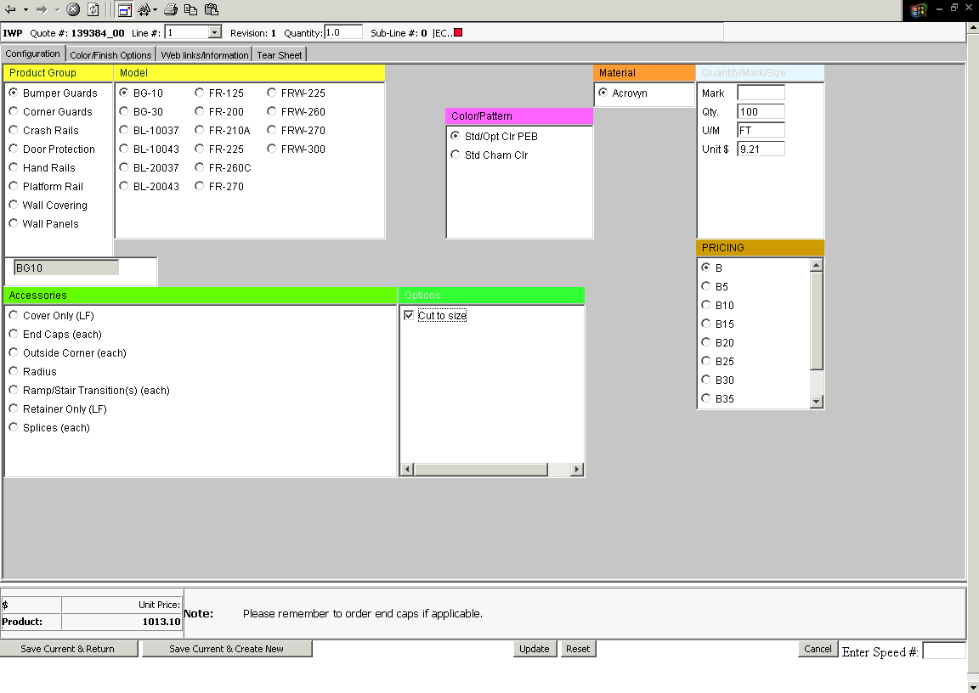
- Cut-to-size option is chosen here, if requested.
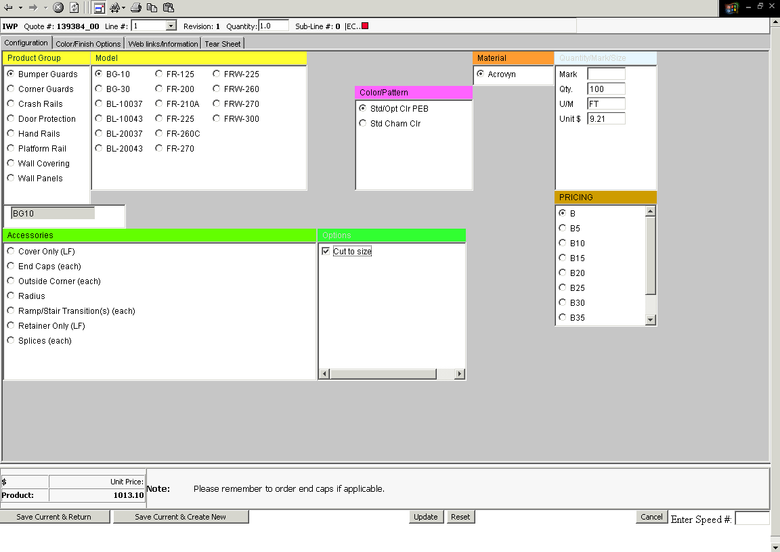
- Once configured, with no violations appearing, click on one of two buttons in the lower left:
- Two options are available:
- Save Current and Create New – Click on this to save the current configuration and continue to enter similar configurations. Use this option to add accessories such as end caps, corners, brackets, or other available accessories (dependent on product). You must select and save each item individually. If you are changing products, be sure to hit the “reset” button on the lower part of the screen when changing models. The line number on the line item list is incremented on each save.
- Save Current and Return – Click on this to save the current configuration and return to the line item screen to complete the quote process.
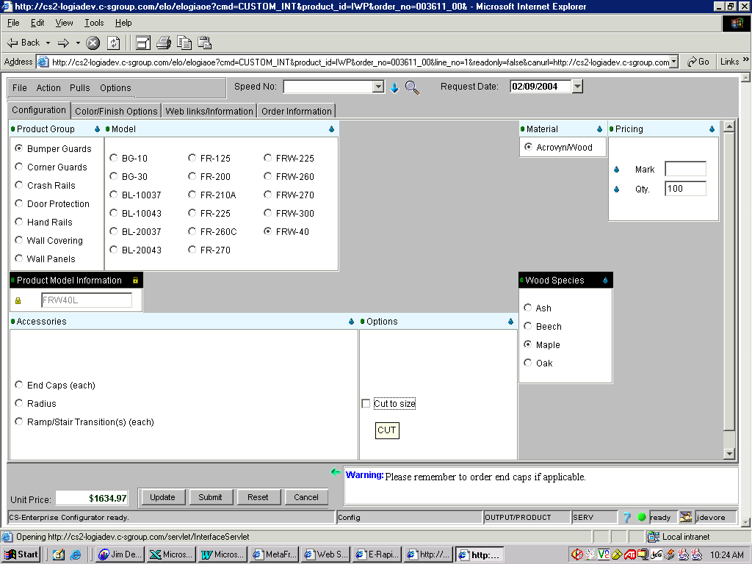
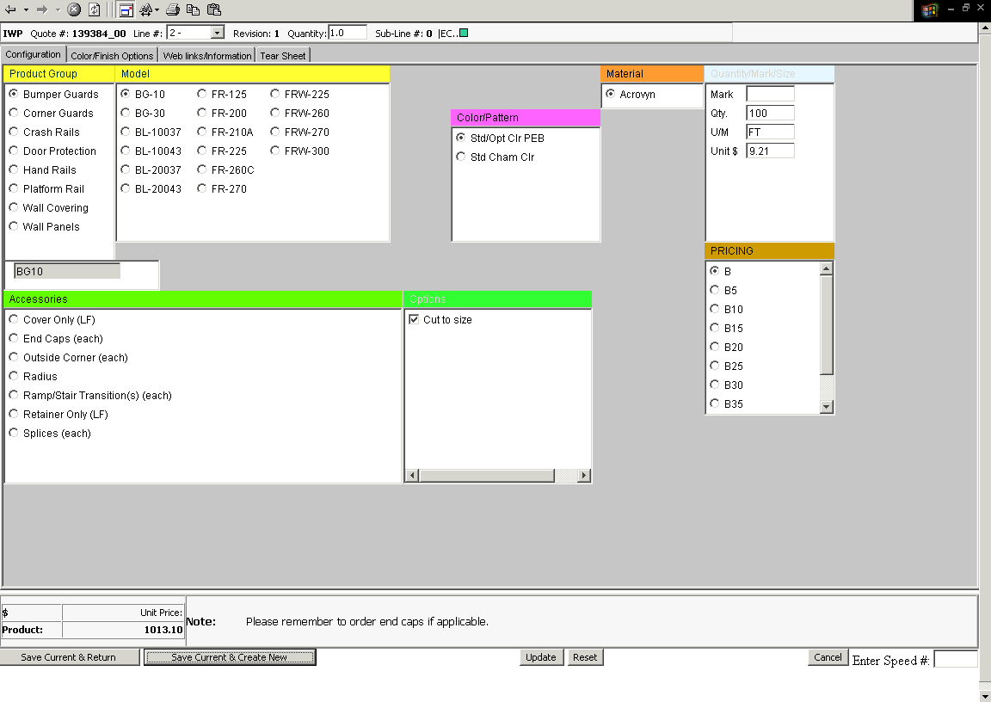
- Here we selected Save Current and Create New to add accessories. Note that cut-to-size selection must be removed. Also note that the line number in the upper left is now 2.
- Click your accessory – and don’t forget to verify your quantity!
- Once configured, the same options apply as previous.

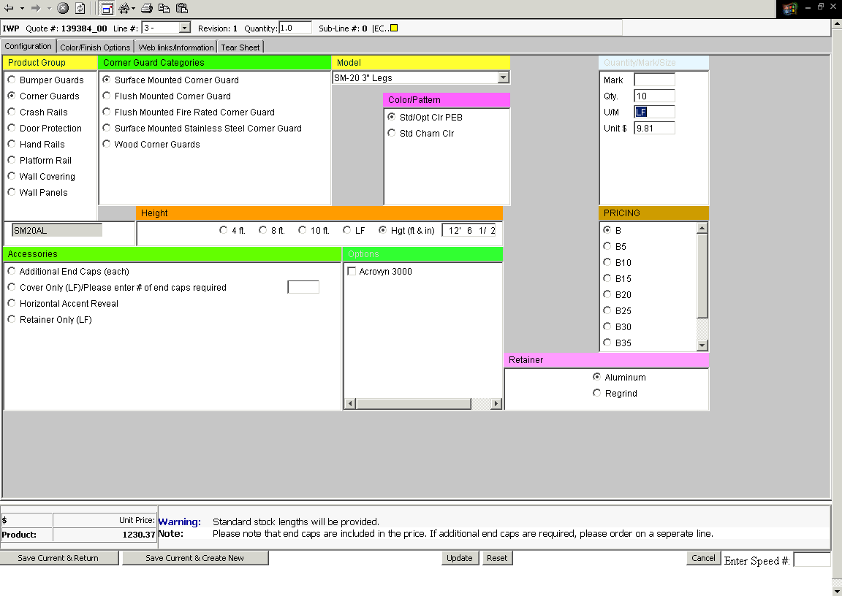
HOW TO ENTER FEET AND INCHES
- Click inside the dimension box
- Type in feet and hit the space bar
- Type in whole inches and hit the space bar
- Type in the numerator if you have fractions of an inch and hit the space bar
- Type in the denominator if you have fractions of an inch and hit update.
- NOTE: When no color option is showing, please be aware that there are no choices and that standard color is being priced. As with all IWP products, if you don't see an option you're looking for, please call the factory for pricing.
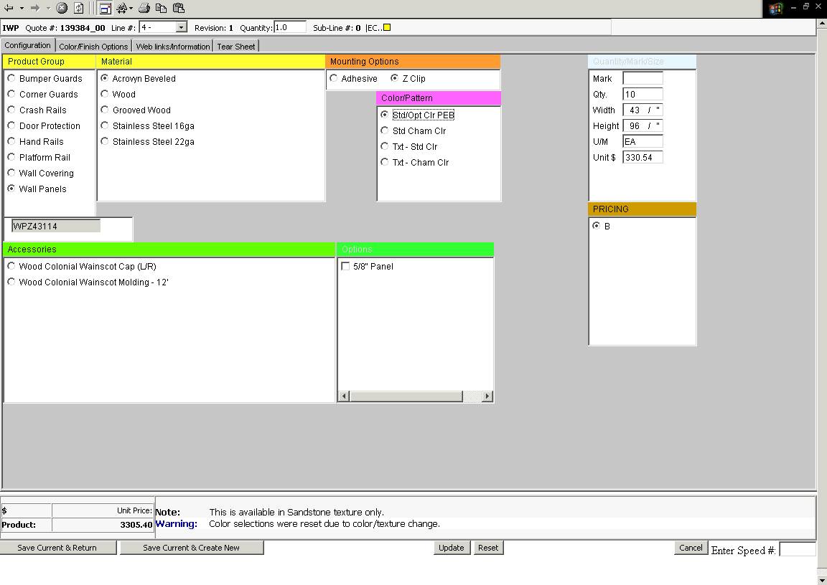
Note that entering width and height for wall panels, wall covering, and door protection follows the same procedure as entering feet and inches, except that all dimensions are in inches.

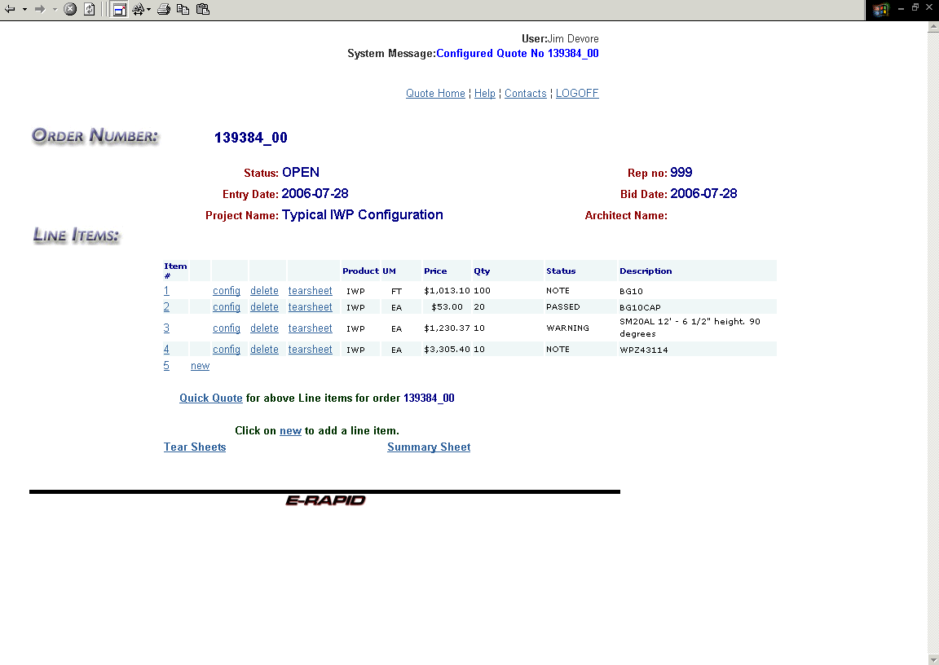
- Once your quotation is complete, you will return to the line item screen. Here there are several options:
- Click on a number in the “Item #” column to return to the header screen.
- Click on “new” to enter a new model configuration.
- Click on “config” to edit an existing line or configuration.
- Click on “delete” to permanently remove the item from the quotation.
- Click on “Quick Quote” to continue to the calculation screen.
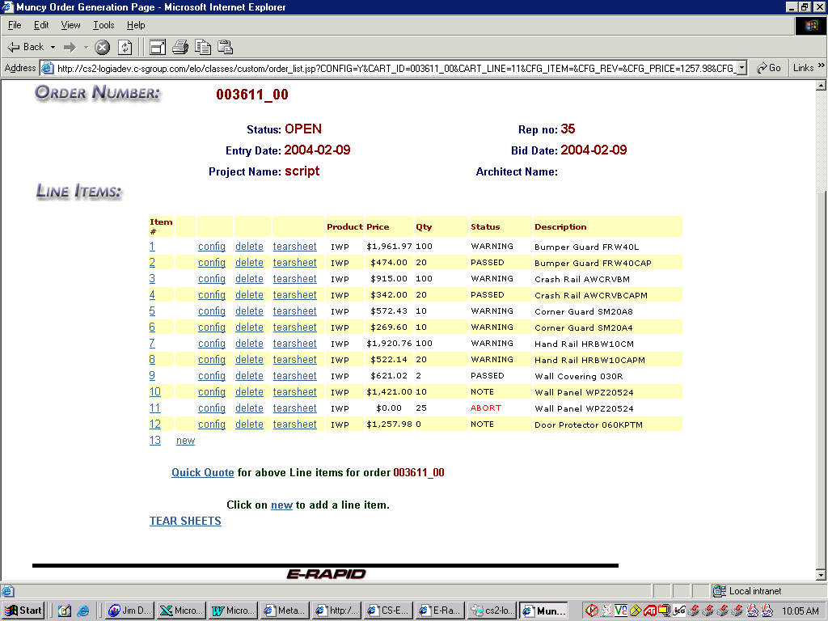
- If you see a red “Abort” error, as in line 11 above, the line contains a major error and is not included in the quoted sale price. Aborts must be corrected before proceeding. Click on the “config” link for that line to make changes.
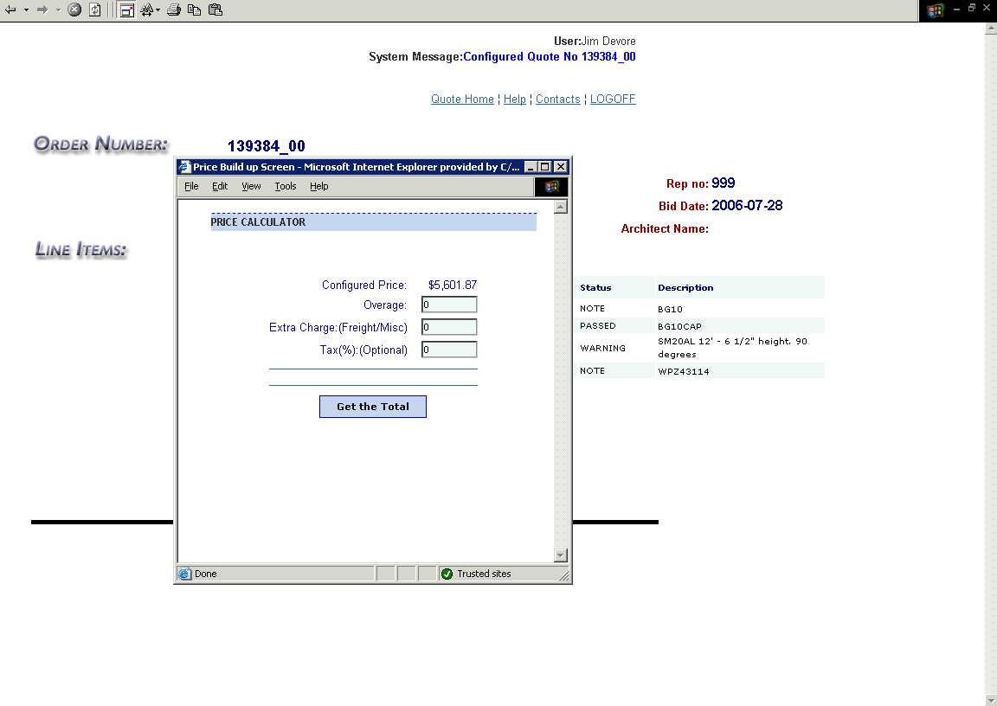
- This screen allows you to add overage, special handling, freight charges, or tax if applicable.
- Hit the “Get the Total” button to advance.
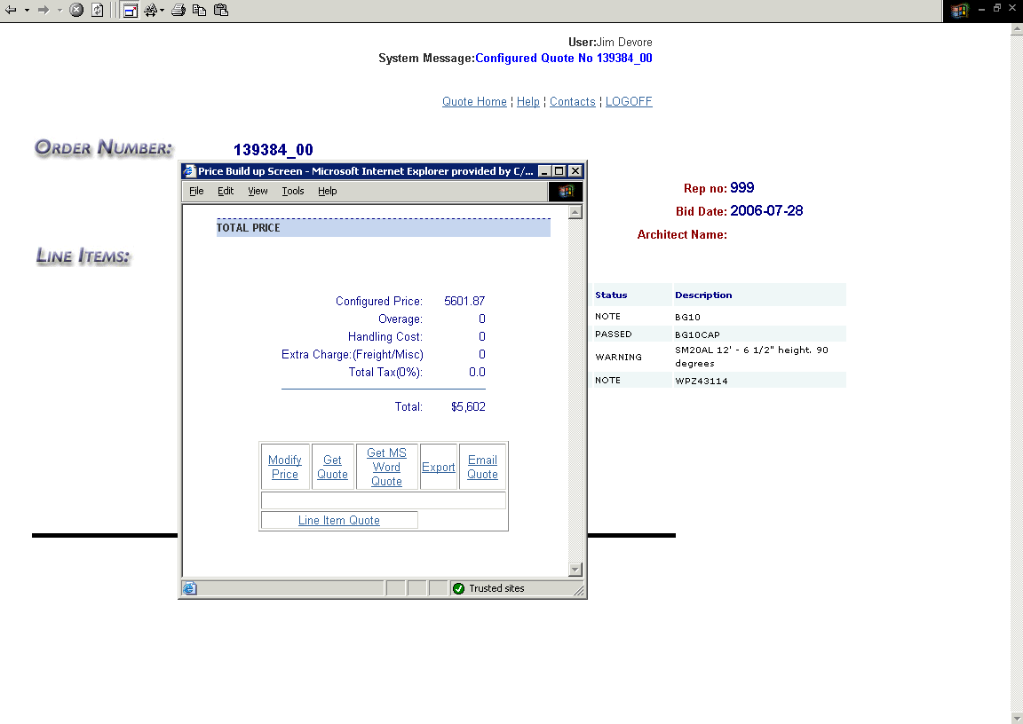
- At this screen you can get the quote in either html (Get Quote and Line Item Quote) or in a word document (Get MS Word Quote). You can also e-mail the quotation (Email Quote) or go back to the price calculator (Modify Price).

